VASAVI COLLEGE OF ENGINEERING (Autonomous)
IBRAHIMBAGH, HYDERABAD-500031
DEPARTMENT OF COMPUTER SCIENCE & ENGINEERING

Name of the Course: Full Stack Web Development

ASSIGNMENT - 1
Name of the Faculty: Susmitha. S | Date of Submission:
Class: B.E.
Section: A
Sem: V
Academic Year: 2026-27

NOTE:
1. Design the user interface (UI) for the following web applications using React,
Bootstrap, or any other front-end framework.

2. All the assignment programs must be uploaded to your respective GitHub accounts. The
same GitHub account should be used for both laboratory exercises and project work.
Organize your work by creating separate folders for assignments, lab programs, and projects
within the repository.

3. Every student, irrespective of the group they belong to, is required to create an "About Me"
(Biodata) page that includes their photograph. The page should be designed using
appropriate CSS styles to ensure a neat and visually appealing presentation.

Set-I (1602-24-733-026, 005, 052, 038, 015, 025, 027)
Q. No. | Description of the question | Marks | BTL  (1/2/3/4/5/6) | Mapped
 |  |  |  | CO | PO
1 | Develop an HTML webpage for a Hospital Management System homepage.  The page should contain:  - Hospital logo and name.  - Departments listed in a navigation menu.  - Doctors' information in a table.  - Emergency contact details.  - Appointment booking form with appropriate HTML input controls.  - Footer containing address and social media links. | 1 | 3 | 1 | 1,2,3
2 | Write HTML code to create a Sudoku puzzle screen. Display a 9×9 Sudoku grid with some pre-filled numbers, puzzle title, timer, and difficulty level. | 2 | 4 | 2 | 1,2,3
3 | - Write a JavaScript program that reads a number from the user and checks whether the given number is an Armstrong number or not.  - Write a JavaScript program that accepts a number from the user and displays whether the number is Prime or Composite. If it is prime, also display all prime numbers up to the given number. | 2 | 3 | 1 | 1,2,3

Set-2 (1602-24-733-060, 055, 058, 031, 037, 017, 057)
Q. No. | Description of the question | Marks | BTL  (1/2/3/4/5/6) | Mapped
 |  |  |  | CO | PO
1 | Write HTML code to create above menu and apply CSS | 1 | 3 | 1 | 1,2,3
2 | Create a bouncing ball animation using HTML and CSS. The ball should continuously bounce up and down within a container. | 2 | 3 | 2 | 1,2,3
3. | Write a JavaScript program that uses the Date object to display the current date, time, day of the week, and current year. | 2 | 3 | 1 | 1,2,3

Set-3 (1602-24-733-010, 036, 061, 008, 029, 059, 035)
Q. No. | Description of the question | Marks | BTL  (1/2/3/4/5/6) | Mapped
 |  |  |  | CO | PO
1 | Write HTML and CSS code to create a LUDO game screen. The page should display the four colored home areas, player tokens, a dice section, player names, and the central winning area. Use CSS to style the board similar to a standard LUDO game. | 1 | 3 | 1 | 1,2,3
2. | Create the following categorized course lists using HTML <select> and <datalist> elements.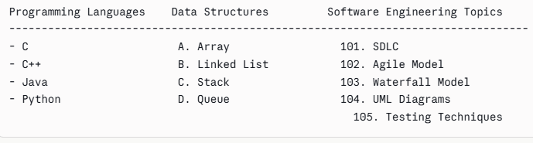 | 2 | 3 | 2 | 1,2,3
3 | Write a JavaScript program to read a number and determine whether it is a Perfect number or not. If it is not a Perfect number, display the nearest Perfect number less than the given number. | 2 | 3 | 1 | 1,2,3

Set-4 (1602-24-733-003, 053, 001, 024, 021, 063, 301)
Q. No. | Description of the question | Marks | BTL  (1/2/3/4/5/6) | Mapped
 |  |  |  | CO | PO
1 | 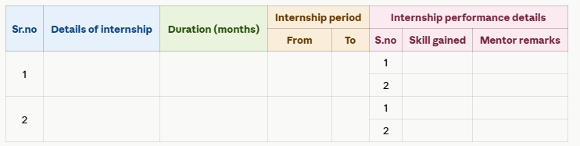  Write HTML code to create above table and apply CSS | 1 | 3 | 1 | 1,2,3
2 | Write an HTML page with JavaScript that accepts a student's marks in five subjects and displays the Total, Percentage, Grade, and Result (Pass/Fail). Validate the input so that each mark is between 0 and 100. Display an appropriate error message for invalid input. | 2 | 3 | 2 | 1,2,3
3 | Write a JavaScript program that displays a countdown timer showing the number of days, hours, minutes, and seconds remaining until the New Year using the Date object. | 2 | 3 | 1 | 1,2,3

Set-5 (1602-24-733-064, 007, 039, 044, 006, 023, 014)
Q. No. | Description of the question | Marks | BTL  (1/2/3/4/5/6) | Mapped
 |  |  |  | CO | PO
1 | 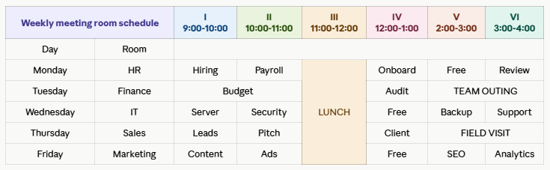  Write HTML code to create the above weekly department schedule table and apply CSS to style it as shown. | 1 | 3 | 1 | 1,2,3
2 | Write an HTML page that contains a drop-down list of 8 Indian states. When the user selects a state, display the following details dynamically:  - Capital  - Official Language  - Population  - State Image (or Logo)  Use CSS to format the displayed information with different font styles, colors, borders, and background. | 2 | 3 | 1 | 1,2,3
3 | Design and develop a web-based Student Registration Form using HTML, CSS, and JavaScript. The form should collect the following details: Student ID, Name, Date of Birth, Gender, Email, Mobile Number, Branch, Semester, Address, and Password. Implement client-side validation to ensure all mandatory fields are correctly filled. Display a confirmation message after successful validation. | 2 | 3 | 2 | 1,2,3

Set-6 (1602-24-733-043, 045, 050, 046, 302, 054, 011)
Q. No. | Description of the question | Marks | BTL  (1/2/3/4/5/6) | Mapped
 |  |  |  | CO | PO
1 | 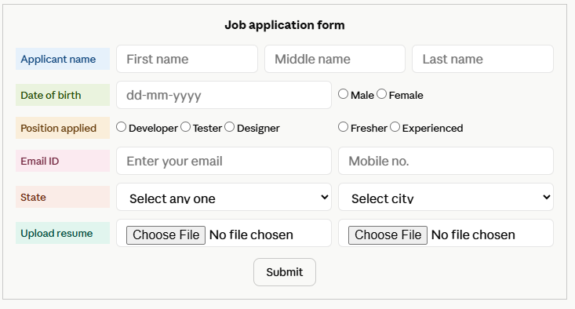  Write HTML code to create the above form and apply CSS | 1 | 3 | 1 | 1,2,3
2 | Write JavaScript to validate the following fields of an Online Banking Registration Form.  a. Customer Name (Only alphabets and spaces are allowed).  b. Account Number (Should contain exactly 12 digits).  c. PAN Number (Must follow the standard PAN format).  d. E-mail ID (Must be in valid format).  e. Password and Confirm Password (Both passwords should match and contain at least 8 characters). | 2 | 3 | 2 | 1,2,3
3 | Develop a web application that accepts the user's name and attendance percentage. If the attendance is less than 75%, display "Sorry <Name>, you are not eligible to appear for the examination." Otherwise, display "Welcome <Name>, you are eligible to appear for the examination." | 2 | 3 | 1 | 1,2,3

Set-7(1602-24-733-028, 048, 016, 056, 062, 303, 018)
Q. No. | Description of the question | Marks | BTL  (1/2/3/4/5/6) | Mapped
 |  |  |  | CO | PO
1 | Design an online course registration form using appropriate HTML form elements. Based on the selected course(s), dynamically display the total course fee, duration, and eligibility using JavaScript. Apply suitable CSS styles to enhance the user interface. | 1 | 3 | 1 | 1,2,3
2 | 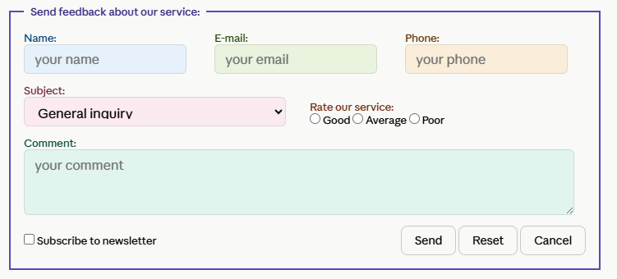  Write HTML code for the above feedback form | 2 | 3 | 2 | 1,2,3
3. | Develop and demonstrate a JavaScript program that uses prompt() to accept a positive integer from the user. Implement an appropriate function to evaluate the factorial of the entered number and display the output using an alert() dialog box. | 2 | 3 | 1 | 1,2,3

Set-8 (1602-24-733-034, 305, 020, 002, 033, 047, 304)
Q. No. | Description of the question | Marks | BTL  (1/2/3/4/5/6) | Mapped
 |  |  |  | CO | PO
1 | Develop a JavaScript program to validate the fields of a Student Registration Form with the following conditions:  a. Student ID: Should begin with "S" followed by exactly 5 digits.  b. Student Name: Should contain only alphabets and spaces, with a minimum length of 5 characters.  c. Email Address: Should follow the standard format (username@domain.com).  d. Mobile Number: Should contain exactly 10 digits and must begin with 6, 7, 8, or 9.  e. Password: Should contain a minimum of 8 characters, including at least one uppercase letter, one lowercase letter, one digit, and one special character. | 1 | 3 | 2 | 1,2,3
2 | Write HTML and CSS code to design a live Cricket Match Scoreboard. The webpage should display the tournament name, venue, team names with their respective team colors, team logos, current score, overs, wickets, current batsmen, bowler details, required run rate, and match status. The leading team's score should be displayed using a larger font size, different font family, and highlighted background. Include a table displaying the batting scorecard of the top five players. | 2 | 3 | 1 | 1,2,3
3. | Develop and demonstrate JavaScript with POP-UP boxes and functions for the following problem:  Input: A positive integer n obtained using prompt().  Output: Display the factorial and the sum of the digits of n using alert(). | 2 | 3 | 2 | 1,2,3

Set-9 (1602-23-733-013, 041, 306, 049, 1602-23-733-061,004, 009)
Q. No. | Description of the question | Marks | BTL  (1/2/3/4/5/6) | Mapped
 |  |  |  | CO | PO
1 | Design a webpage for a College Technical Fest using HTML and CSS. The page should contain a header with the fest name, navigation menu, event details, registration fee table, coordinator information, and a footer with contact details. Apply suitable CSS styles for layout, colors, fonts, and borders. | 1 | 3 | 1 | 1,2,3
2 | Write a JavaScript program to change the font style (Arial, Times New Roman, Verdana) of a paragraph based on the user's selection from a drop-down list. | 2 | 3 | 2 | 1,2,3
3 | Create an external style sheet to design a College Student Profile webpage. The page should include the student's photograph, personal details, educational qualifications, technical skills, and contact information with an attractive layout. | 2 | 3 | 1 | 1,2,3

Set-10 (1602-24-733-019, 022, 030, 032, 042, 051, 065, 307)
Q. No. | Description of the question | Marks | BTL  (1/2/3/4/5/6) | Mapped
 |  |  |  | CO | PO
1 | Design a web-based Student Admission Form to collect the applicant's details such as Student ID, Name, Date of Birth, Gender, Email, Mobile Number, Course, Address, and Parent's Contact Number. Write the necessary JavaScript validation scripts for all mandatory fields before form submission. | 1 | 3 | 2 | 1,2,3
2 | Design the static web pages (Home, Registration, Login, Product Catalog, Product Details, Shopping Cart, Contact Us) required for an online electronics store website using HTML and CSS.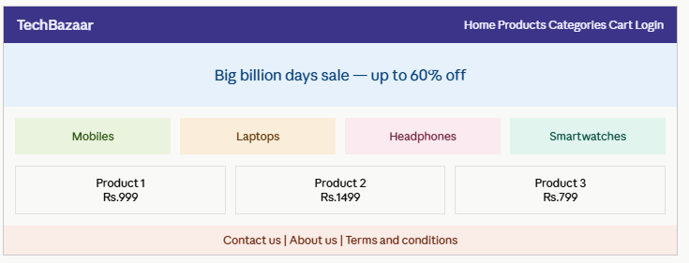 | 2 | 3 | 1 | 1,2,3
3 | Write an HTML page including any required JavaScript that takes a temperature value from a text field in the range of -50 to 150 (in Celsius) and convert it to Fahrenheit, displaying the result on the same page. It should not accept values outside this range, alphabets, or special characters. | 2 | 3 | 1 | 1,2,3

